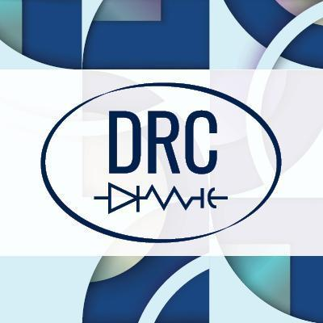

Virtual Platform User Guide
DRC 2022
HOW TO LOGIN TO UNDERLINE

HOW TO LOGIN TO UNDERLINE

- An email with a password-creating link will be distributed by Underline to all Registered DRC 2022 attendees around June 23rd to make it easy for first-time users of Underline to create the password for their respective accounts (named by email address used when you registered!).

When you are logged into your Underline account, please follow this link to the DRC 2022 Conference event page: https://underline.io/events/320/reception.

- If you did not receive an invitation, please first check your spam folder, and/or any similar folders that are not your main inbox (such as social, or promotions, junk folder …) and look for an email by Underline (no-reply@app-mail.underline.io).
Please DO NOT try to create an account on your own, as that will return an error message. Underline has already created your account and ticket for the event.

- If after June 25th, you are still unable to find the email, please contact our support team at: DRC2022@underline.io

- If after June 25th, your Underline account has not been authorized to access the DRC 2022 Conference event (you receive a ‘You need to register’ message), please contact our support team at: DRC2022@underline.io
HOW

WALK THROUGH VIDEO

Please watch this short video that will explain how to navigate the Underline virtual platform: https://somup.com/c31Y3etJtH

GETTING AROUND THE UNDERLINE SITE

- All sessions can be found via the menu item “Sessions”, in the left toolbar.
- All poster sessions can be found under the ‘’Posters” icon on Underline.
- The “Expo” menu item includes links to our official exhibitors and their promotional pages
- The Help desk includes a link to video tutorials, instructions etc. – Please visit our HELP DESK first to familiarize yourself with the Event page before the conference begins.
- If you cannot find the answer you are looking for, please use the ‘’Request a meeting’’ button on the right and our Support Team staff will reply.

HOW ORAL SESSIONS WILL RUN

- All sessions are accessible from the event’s schedule and/or the sessions tab
- To join an oral session, click on the ‘’Join Zoom Room’’ button. This will take you to a room where that session takes place. You can ask questions as you would in any other Zoom meeting. Each session will have a Chair running the Q&A.
- A full-featured search bar on the “Sessions” page allows search by lecture

HOW VIRTUAL POSTER SESSIONS WILL RUN

- All posters can be found in the schedule or by clicking on the POSTERS tab.
- Your poster tile features the information you submitted about your poster
- There is a Q&A box on the right hand side of the poster. All poster presenters, whether in-person or virtual, should read and respond to the Q&A.
- If you are presenting virtually, please post your web conference link in the Q&A tab, which registrants will use to contact you during the poster session

AFTER THE CONFERENCE

- Underline will release unedited live session recordings within 24 hours after the actual session.
- Underline will release edited talk recordings within 7 days after the conference.
- All content will be available on Underline
- Each paper (platform, poster, tutorial, keynote) will receive a separate page on Underline with all metadata that was submitted by the presenter. Each paper will have an individual Q&A box where all attendees can continue the conversations in a text form after the event.

For any additional questions, please contact the Underline support at DRC2022@underline.io

Enjoy the conference!
The DRC 2022 & the Underline teams

