EMC Abstract Submission Instructions

Step 1: Title/Body

- Copy the abstract title into the appropriate box. Enter the title in mixed case. Please do not use all capital letters, bold type, underlining or other formatting.

Example of Mixed Case: Some Defect Types in Intermetallics and Their Consequences
- Enter a text only description of your research. This should be 4000 characters or less. Do not include figures or tables in this section. This text abstract will appear in the conference program book if accepted.
- Special characters can sometimes paste incorrectly. Use the ‘Insert Special Character’ button to replace them.

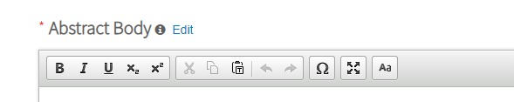
- IMPORTANT! PLEASE READ!
- REQUIRED Extended Abstract Upload (must be an image file**): This one page file should include pictures, tables, or any materials that may aid in the evaluation of your submission. This file will not be published, and will be solely used by the conference organizers in their review of your abstract. It is REQUIRED and your abstract will not be reviewed without this submission.
- Your extended abstract may be submitted as a single graphics file in gif, png, tiff, tif, jpg, or jpeg format. File size is limited to 20 MB, and file resolution of 96 dpi or higher is recommended.
- Suggested options for generating a graphics file for upload:
  - Conversion from PDF file (requires Adobe Acrobat): Place and arrange your figures, tables, etc on one 8 ½” by 11" letter size page (with 1 inch margins). Open the file in Adobe Acrobat and use the 'Save As' feature to save the PDF file as an image file.
  - Conversion from Microsoft PowerPoint: Place and arrange your figures, tables, etc, on a single slide (in portrait orientation, 8 ½’ by 11"). In PowerPoint, use the ‘Save As’ feature and select a graphics file format to save the slide as an image.
- **If you have difficulty creating or submitting an image file, contact Marla Boots at boots@mrs.org. Include a PDF file, the control id number (located in the right corner at the top of the abstract document page) and your name. Continue to fill out the abstract submission form and save it as a draft. Marla Boots will save your pdf as an image, upload it and submit your abstract. Once the abstract is submitted, she will send you an abstract proof.
- CAPTION—Please add the abstract control id number in the caption section when uploading your extended abstract. The abstract control id number can be found at the top of the abstract submission page on the right side preceded by “ID:”. To enter it in the caption section, click on ‘Add Caption’. Once screen appears, enter Control ID: followed by your control id number. For example: Control ID: 2686188
- Click the submit button when completed.

- Select ‘save and continue’.

Step 2: Properties
- Presentation Type
- Select the ‘presentation type’ button to choose your preferred option.
- Only presenters who have been specifically invited by the symposium organizer should select ‘invited speaker’.
- Students should choose either Student No Preference, Student Oral Presentation Preferred or Student Poster Presentation Preferred in order to be considered for the Student Best Paper award or Student Best Poster award.
- This is your preferred method of presentation only. The organizers have the final decision as to which abstracts are scheduled for an oral or poster presentation.

- Symposium Choice
- When choosing a symposium during submissions, we realize that topical areas do overlap in some cases. The authors should use their best judgment to select the topical area with the best fit to their abstract.
- The abstract submission website now allows a second, optional topical area to be selected.
- Do not submit your abstract to more than one symposium as we check for duplicate abstract submissions and you will be asked to choose if you do this.
- Researchers in computational physics are encouraged to submit their abstracts to a session that includes experimental work on their material system.
- The program committee may move abstracts to related topical areas if rearrangement produces better session flow or to accommodate schedule constraints.

- Keywords
Select up to three keywords from the dropdown.

- Select ‘save and continue’.

Step 3: Authors

- The person submitting the abstract is considered the contact author but is also loaded as the presenting author and the first author. Their affiliation information is automatically loaded as well. All of this information can be edited using the appropriate buttons.
- To edit an affiliation, select the ‘edit’ button and enter the information as you would like it to appear
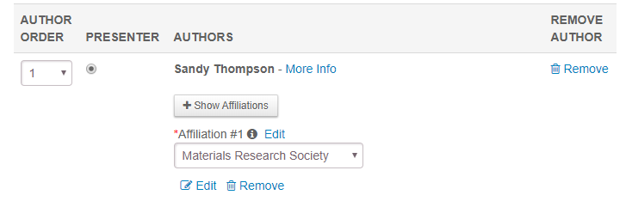
- If you wish to add additional authors, select the ‘Add Author’ button.
- The following will appear:

- For best results, search for the author by e-mail address first. If the e-mail doesn’t bring up the author for whom you are searching, clear the e-mail info and search next by last name.

- If the author is in the system already, their name will show in the ‘add author’ list.

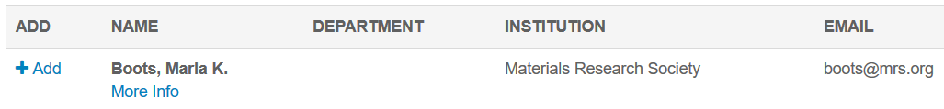

- If the author is not found in your search, select the ‘Create An Author’ button and enter the required information.
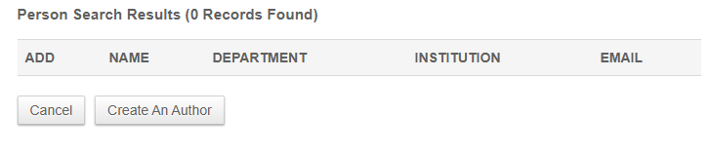
      - Be sure to enter the co-author’s name in the proper case. Names should not be in all caps or all lower case. If you make a mistake while entering a name, continue with your submission and then notify meetings@mrs.org that you need a name correction. You cannot edit names from the submission site.

      - When all of the information is entered, click the ‘Submit Created Author’ button. The author will now be added to the author list. NOTE: Clicking ‘Save’ will NOT save the co-author you just entered. If you click ‘Save’ before clicking ‘Submit Created Author’, the entry will be lost.

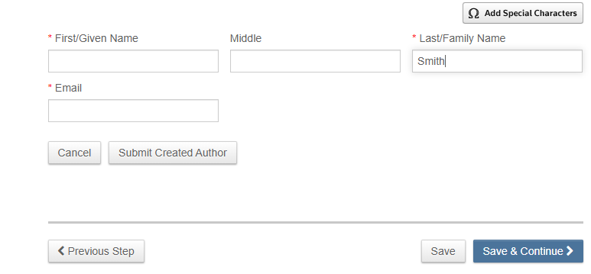

Adding an Affiliation

- If the newly added author shares an affiliation with an existing author, do not add a new affiliation; choose the affiliation by clicking on the appropriate affiliation in the drop down menu.
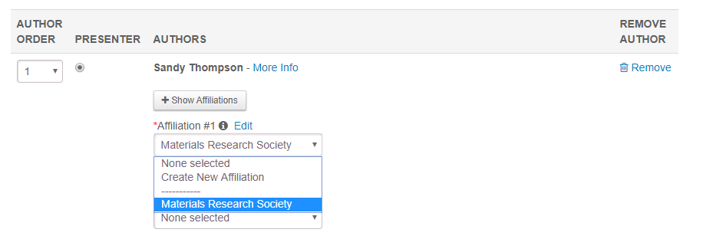
- If the author has an affiliation that is NOT listed in the dropdown menu, select ‘Create New Institution’ from the dropdown menu. The following box will appear:
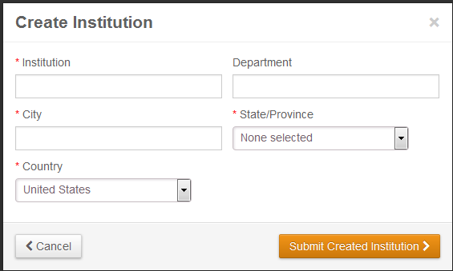
    - Enter the institution information, then click ‘Submit Created Institution’. Fields with a red asterisk are required.
-All institutions should be in mixed case, not all caps or all lowercase.
-Remember that how you enter the institution is how it will be displayed in the program.
Correct: The Pennsylvania State University
Incorrect: psu, penn state, PENN STATE UNIVERSITY
-Check the beginning and end of the department and institutions to ensure that there are no commas or extra spaces.
-Do not include addresses or postal codes in any part of the institution submission.

    - The institution will now be added for that author and is available in the dropdown menu for other authors.
- If an author has more than one affiliation, use the Affiliation #2 and Affiliation #3 boxes to input this information.

Changing Affiliation Order

- To change the order in which the affiliations are numbered, click the ‘Reorder Affiliations’ button which is located at the bottom of the page.

- Using the dropdown numbers, select the preferred order (note that you cannot see the department in this view).
- When you are finished re-numbering, click the ‘Update Affiliation Order’ button.
Changing Author Order
- To change the order in which the authors are listed, use the drop down numbers () next to each author’s name. Be sure that each author has a unique number. When the renumbering is complete, scroll to the bottom and select the ‘Update Author Order’ button.

NOTE: If you do not click ‘Update Author Order’ the order will not be changed and any changes made to the numbering will be lost.

Changing the Presenter

- To change the presenter, click the radio button to the left of the author’s name. Only one presenter can be selected.
Once all authors and affiliations are entered and in the correct order, select the ‘Save & Continue’ button.

Step 5: Review & Submit

- Pay close attention to any warnings that appear at the top of the ‘Review and Submit’ page. Should any warnings appear, go back to the steps listed and correct the information. You will not be able to complete your submission unless the information is corrected.

- Before submitting, click the ‘View Proof’ button at the bottom of the page.

This will open a new window that will show your abstract as it will appear online and in the program. Correct any errors found in the proof by closing the window and returning to the appropriate step number to correct the error.

- If you are satisfied with the way your proof looks, select the ‘Submit’ button at the bottom of the page.

If you cannot see the submit button, there is an error in your submission that you need to correct. If you end your session without selecting the ‘submit’ button, your abstract will remain in draft form. Once submitted, abstracts can be edited until the submission deadline date. Abstracts saved in draft form can also be edited and then submitted until the abstract deadline date. Abstracts left in draft form after the submission deadline will not be reviewed by the organizers. Please contact meetings@mrs.org with any questions.

